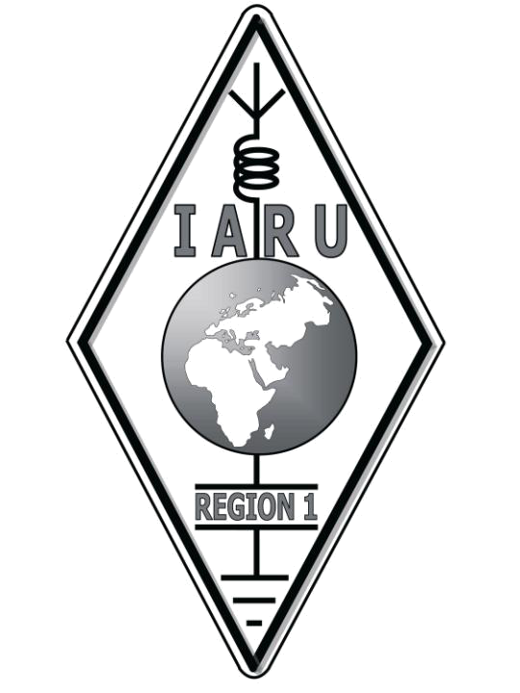
International Amateur Radio Union Region 1
Europe, Middle East, Africa and Northern Asia Founded 1950
Region 1 Office: PO Box 12104, Brandhof, 9324, Republic of South Africa
Tel: +27 51 402 2093 (O) +27 51 446 2039 (H) Fax: +27 088 051 446 2039
Mobile: +27 82 770 9126 E-mail: zs4bs@netactive.co.za or secretary@iaru-r1.org

Ivan Ivanov, LZ1PJ – HSTWG Chairman
P.O.Box 15, BG-1324 Sofia, Bulgaria
tel : +359 888 889493 e-mail: lz1pj@bfra.org, lz1pj@abv.bg

Skopje 13.10.2010
IARU Region 1 High Speed Telegraphy Working Group

Sofia 08.01.2015

Chairman: Ivan Ivanov LZ1PJ
P.O.Box 15, BG-1324 Sofia, Bulgaria
e-mail: lz1pj@bfra.org GSM. +359888889493

Members:

1. ARI Vito Vetrano IN3VST
Via Verdi 27/a, 39012 Merano (BZ), Italy
e-mail: in3vst@tin.it

2. BFRA Iliya Getsov LZ4UU
Hotel Bardoto, Breznik, Bulgaria
e-mail: lz4uu2002@yahoo.com GSM. +359885473270

3. BFRR Andrei Bindasov EU7KI
10-17b Nepokorennykh, 212002 Mogilev, Belarus
e-mail: andrew_eu7ki@hotmail.com GSM: +375297455474

4. CRC Tomas Mikeska OK2BFN
Velky Orechov 121, 763 07 Czech Republic
e-mail: ok2bfn@seznam.cz H.+420577996247 GSM +420775092822

5. DARC Andre Schoch DL4UNY
Keplerstrasse 6, 98693 Ilmenau, Germany
e-mail: dl4uny@darc.de GSM.+4917696932940 H.+4936776679282

6. FRR Georghe Paisa YO8WW
e-mail: yo8ww@yahoo.com GSM: +40740611624

7. HRS Milan Drlic 9A2WJ
Ante Jaksica 11, HR-10000 Zagreb, Croatia
e-mail: daki@9a2wj.com GSM: +38598638112 H . +38512435237

8. MRASZ Laszlo Weisz HA3NU
Zrinyi u. 99, H-7100 Szekszard, Hungary
e-mail: ha3kna@tolna.net GSM. +36204292209 H. +3674412030

9. MRSF Mijiddorj Dashchantsal JT1CP
MRSF, P.O.Box 573, Ulaanbaatar, Mongolia
e-mail: mijid_50@yahoo.com H: +976-357134, GSM: +976-99128650

10. PZK Marek Kluz SP8BVN
23-414 Cegielnia Markowicze 3/2; Poland
e-mail: sp8bvn@poczta.onet.pl GSM: +48607840210, H: +4884 6851297

11. RSM Mladen Markovski Z32M
Ul. Edvard Kardelj 15-3/3 1430 Kavadarci, Macedonia
e-mail: ntehnika@yahoo.com H:+38943416644 GSM:+38975487933

12. SRR Elvira Aryutkina UA4FJ
Ul. Kalinina 61/43, 440052 Penza, Russia
e-mail: ua4fj@rambler.ru GSM:+79273771007 W:+78412564294

13. SRS Dusan Ceha YU1EA
Vinogradski venac 22/6, 11136 Beograd, Serbia
e-mail: dusan.ceha@gmail.com GSM: +381641130590 H. +381112505310

14. SSA Ingemar Myhrberg SM0AIG
Arhusgatan 98, SE16445 Kista, Sweden
e-mail: sm0aig@ssa.se H: +4687514850, GSM: +46707514851

15. URAL Svitlana Zdorevska UT5URM
13 Gmyri str., apt.165, Kyiv 02140, Ukraine
e-mail: 111@freenet.com.ua GSM: +380935510016, H: +380445731035
* Svitlana recently resigned as WG member. I will keep her temporarily as contact person until clearing the question with future Ukraine participation.

16. USKA Fritz Zwingli HB9CSA
e-mail: zwinglihaus@t-online.de GSM:+496251790019

IARU R1 HSTWG Chairman
Ivan Ivanov, LZ1PJ

